Practical 1

The following data represents the scores made in an intelligence test by two groups of students from section A and section B of a college.

|  |  |  |  |
| --- | --- | --- | --- |
| Student_No. | Section A |  | Section B |
| 1 | 9 |  | 10 |
| 2 | 8 |  | 8 |
| 3 | 10 |  | 6 |
| 4 | 6 |  | 8 |
| 5 | 7 |  | 9 |
| 6 | 8 |  | 8 |
| 7 | 5 |  | 7 |
| 8 | 6 |  | 8 |
| 9 | 7 |  | 5 |
| 10 | 8 |  | 8 |

Test Which Group is more Consistent.

Solution:

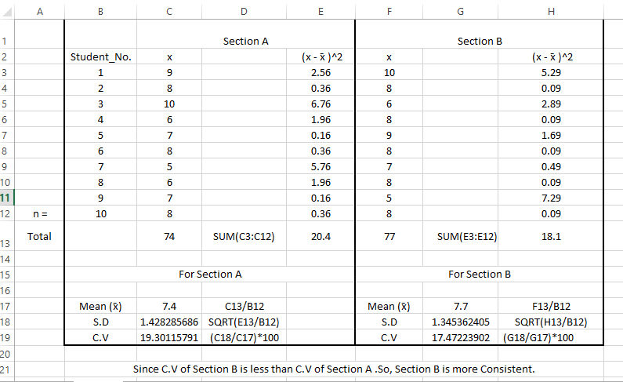

Practical 2

The following data gives the number of minutes required for 15 boys and 15 girls students of a class to complete a task.



Test Which Group is more Consistent.

Solution:

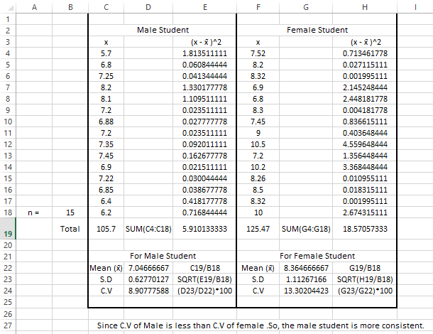

Practical 3

A part of the investigation of the collapse of the roof of a building, a testing laboratory is given all the available bolts that connected the steel structure at 3 structure at 3 different positions on the roof. The forces required to shear each of these bolts are as follows:

|  |  |  |  |  |  |  |  |
| --- | --- | --- | --- | --- | --- | --- | --- |
|  |  |  |  |  |  |  |  |
| position 1 | 90 | 82 | 79 | 98 | 91 |  |  |
| position 2 | 105 | 89 | 93 | 104 | 89 | 95 | 86 |
| position 3 | 83 | 89 | 80 | 94 |  |  |  |
|  |  |  |  |  |  |  |  |

Perform an analysis of variance to test at 0.05 level of significance whether the differences among the sample means at the 3 positions are significant.

Solution:

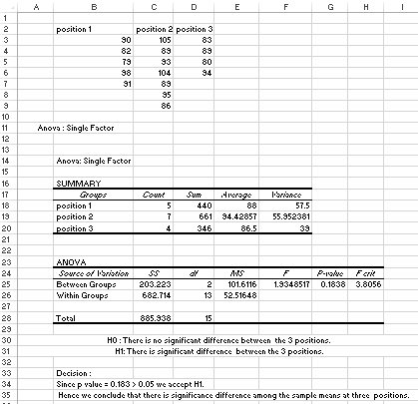

Practical 4

The following are the numbers of mistakes made in 5 successive days for 4 technicians working for a 4 technicians working for a photographic laboratory:



Test at the level of significance 0.05 whether the differences among the 4- sample means can be attributed to chance.

Solution:

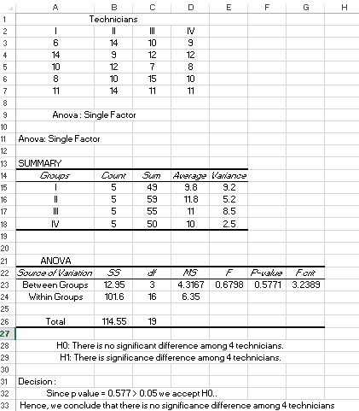

Practical 5

The following are per acre production data for three varieties of wheat, each grown on 4 plots and state if the variety differences are significant.



Solution:

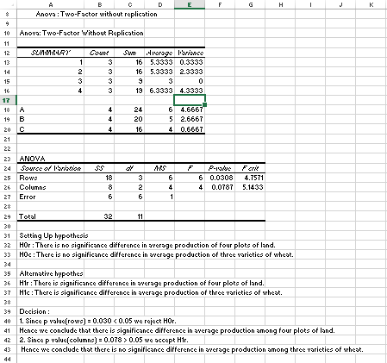

Practical 6

Fit normal distribution to the following data and find expected frequencies.



Solutions:

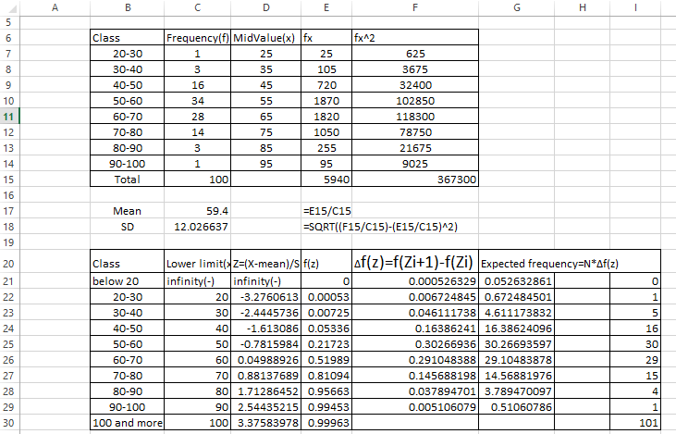

Practical 7

Fit the Poisson distribution and find mean.

|  |  |  |  |  |  |  |  |  |
| --- | --- | --- | --- | --- | --- | --- | --- | --- |
| x | 0 | 1 | 2 | 3 | 4 | 5 | 6 | 7 |
| f | 71 | 112 | 117 | 57 | 27 | 11 | 3 | 1 |

Solution:

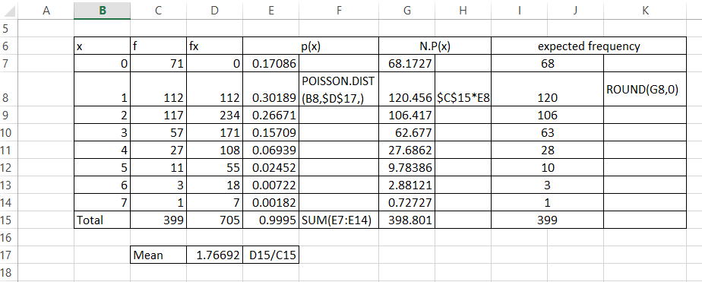

Practical 8

Find the Poisson distribution and find mean.

|  |  |  |  |  |  |  |
| --- | --- | --- | --- | --- | --- | --- |
| mistake package | 0 | 1 | 2 | 3 | 4 | 5 |
| number of packages | 142 | 156 | 69 | 27 | 5 | 1 |

Solution:

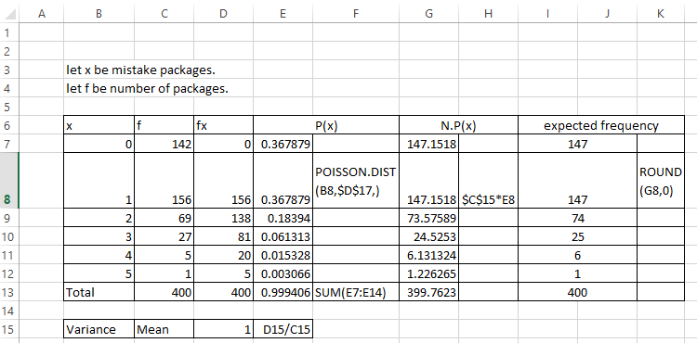

Practical 9

Find the Binomial distribution and find the expected frequencies for the following data.

|  |  |  |  |  |  |  |  |
| --- | --- | --- | --- | --- | --- | --- | --- |
| x | 0 | 1 | 2 | 3 | 4 | 5 | 6 |
| f | 7 | 6 | 19 | 35 | 23 | 7 | 1 |

Solution:

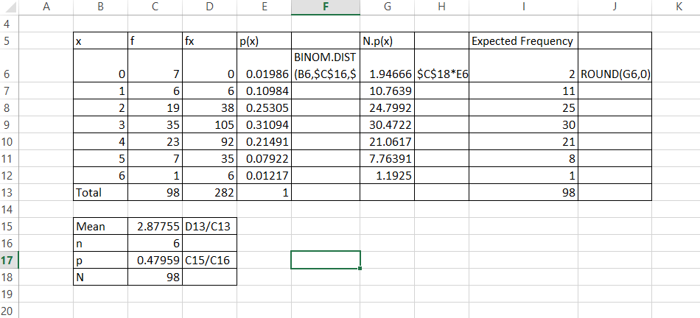

Practical 10

Omprakash Sharma, owner of the Kathmandu Precast Company, has hired you as a part-timer analyst. He was extremely pleased when you uncovered a positive relationship between the number of building permits issued and the amount if work available to his company. Now he wonder if it’s possible to use knowledge of interest rates on first mortgages to predict the numbers of building permits that will be issued each month. You collect a sample of data covering nine months.

|  |  |  |  |  |  |  |  |  |  |
| --- | --- | --- | --- | --- | --- | --- | --- | --- | --- |
| X | 10.2 | 12.6 | 13.5 | 9.7 | 10.8 | 9.5 | 10.9 | 9.2 | 14.2 |
| Y | 786 | 494 | 289 | 892 | 343 | 888 | 509 | 987 | 187 |

1. Calculate the correlation coefficient between building permits and interest rate and let its significance at 1%.
2. Estimate the best fitting regression line and compute residual for month 9.
3. Compute the coefficient of determination and interpret its meaning.
4. Predict building permits when the interest rate increases by 9.7%.

Solution:

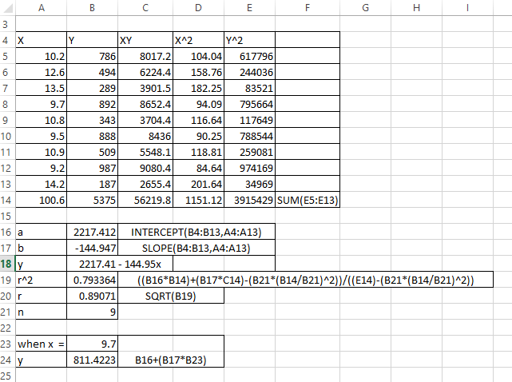

Practical 11

Career airline pilots faces the risk of progressive hearing loss due to noisy cockpit noisy cockpits of most jet aircrafts. Much of the noise comes from engines but from air roar which increases at high speeds. To assess this workplace hazard a pilot measured cockpit noises level (in decibels) and airspeed. The data are shown in the given table.

|  |  |  |  |  |  |  |  |  |  |  |
| --- | --- | --- | --- | --- | --- | --- | --- | --- | --- | --- |
| X | 250 | 340 | 320 | 330 | 346 | 260 | 280 | 395 | 380 | 400 |
| Y | 83 | 89 | 88 | 89 | 92 | 85 | 84 | 92 | 93 | 96 |

1. Determine association between noise level and air roar which is increased due to high speed. Comment on strength of association
2. Develop a least square regression model to estimate the noise level with the help of speed of aircraft. Also interpret the regression coefficient.

Solution:

